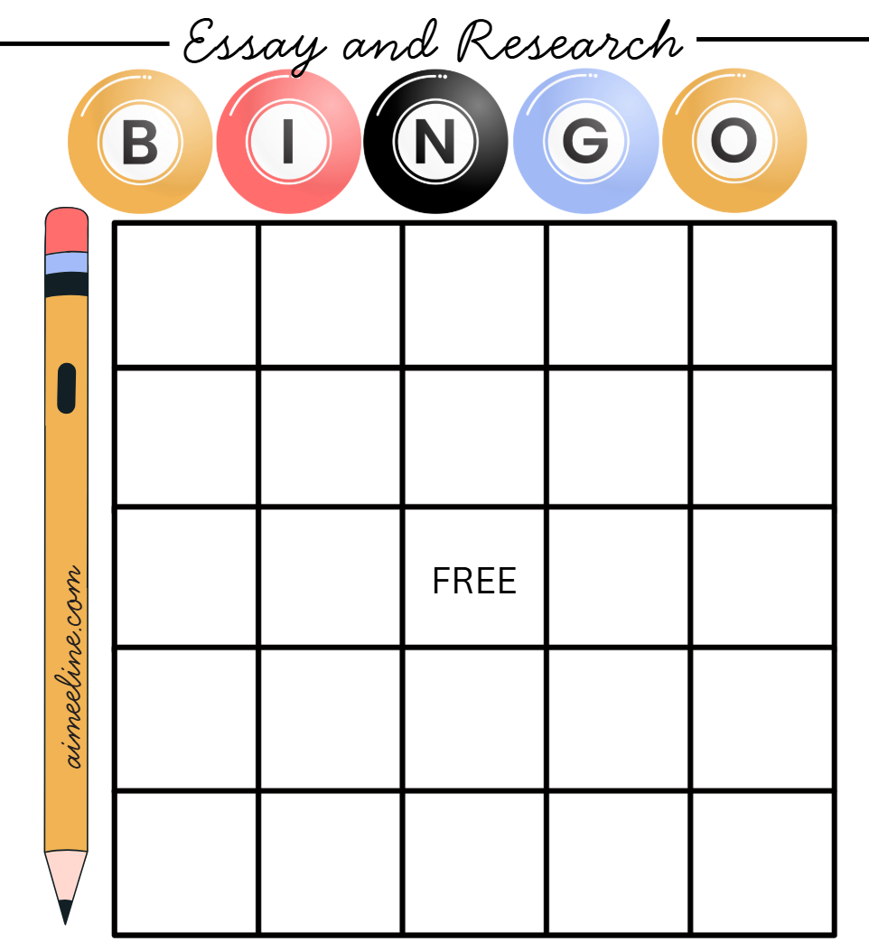
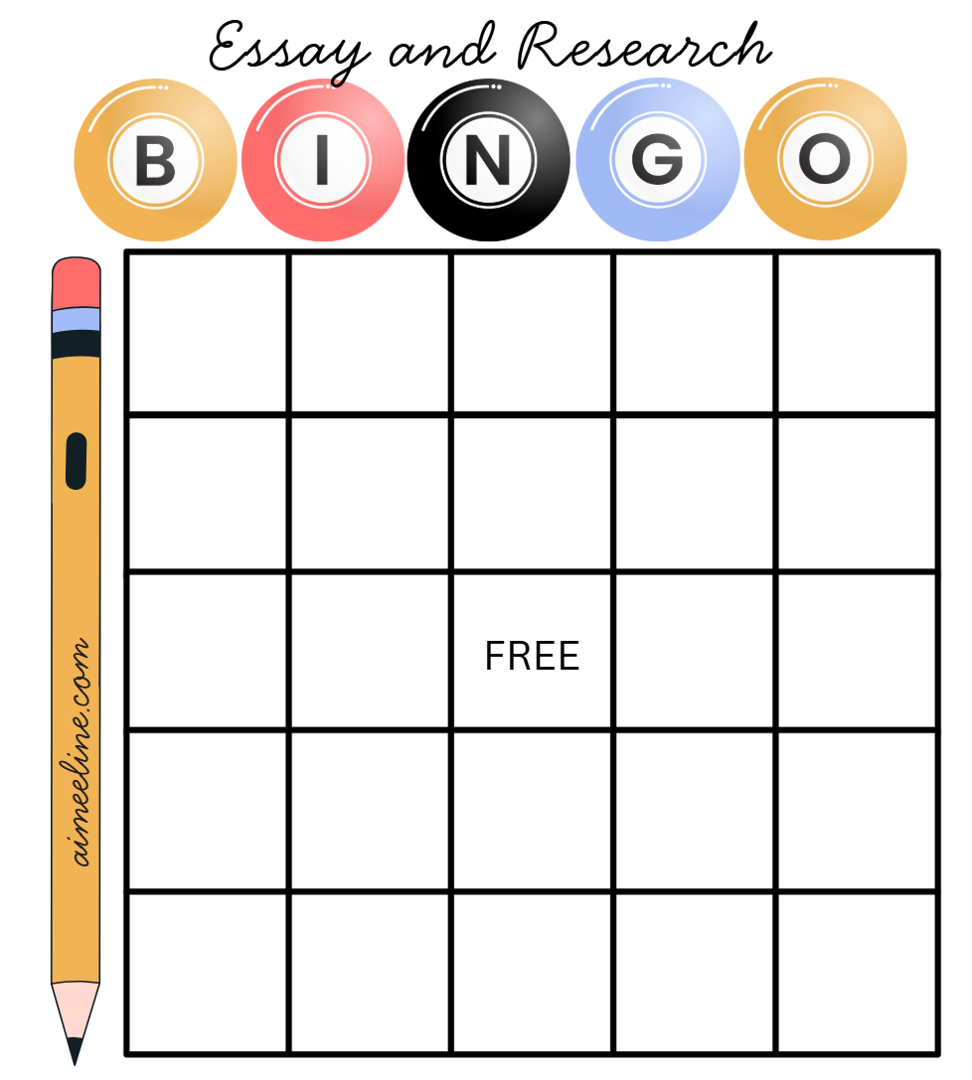
Set Up: Write one essay or research term from the WORD BANK below in each square above. Strategize: Use the 24 words you understand best. Ten words will be left over. Play: When the game moderator calls a definition that matches a term on your card, place an object or a mark on that square. Call BINGO when you have marked five terms in a row horizontally, vertically, or diagonally. The moderator will check your terms against the list of terms that have been called before declaring a winner.

WORD BANK: Annotate, appositive, attention grabber, bibliography, body paragraph, clausal thesis, clincher sentence, comparison/contrast, conclusion paragraph, descriptive, graphic organizer, in-text quotation, indent, introduction, MLA documentation, MLA format, MLA header, note cards, note pages, outline, parallelism, paraphrase, parenthetical citation, persuasive, plagiarism, research, source, summarize, supporting evidence, thesis statement, transitions, topic sentence, static, supporting evidence, URL, working thesis, Works Cited

Moderator Call Sheet
Moderator Instructions: Use the chart below to record the terms you called in each BINGO round. Choose level of play (Easy or Challenging).
Easy: Call out the terms themselves.
Challenging: Call our definitions instead of terms. Definitions are suggestions only. Feel free to substitute with your own hints.
Essay and Research Term | Definition (suggestion only) | Round
Essay and Research Term | Definition (suggestion only) | 1 | 2 | 3
- Annotate | To add explanatory notes
- Attention grabber | First sentence of the introduction paragraph
- Bibliography | List of sources consulted but not quoted
- Body paragraph | Essay paragraphs occurring after the intro and before the conclusion
- Clausal thesis | States the essays purpose while allowing the writer to present two sides of an issue
- Clincher sentence | Final sentence of a body paragraph
- Comparison/contrast | Essay which presents similarities and differences regarding at least two subjects
- Conclusion paragraph | Final paragraph of an essay
- Descriptive | Type of essay which describes various aspects of a subject, often relying on sensory detail
- Graphic organizer | Method of organization employing shapes and spaces
- In-text quotation | Material from an outside source placed inside quotation marks
- Indent | A space denoting a paragraph beginning
- Introduction | First essay paragraph
- MLA documentation | Standardized rules for recording source information
- MLA format | Standardized rules for font size, margin width, and paragraph spacing
- MLA header | Standardized rules for student’s personal information on papers
- Note cards | Traditional method of archiving bits of researched information
- Note pages | Modern method of archiving bits of researched information
- Outline | Traditional, linear method of organizing paper structure
- Parallelism | Words, phrases, or clauses presented in similar grammatical structure
- Paraphrase | In your own words
- Parenthetical citation | Truncated source information placed inside parenthesis after quoted material
- Persuasive | Type of essay which seeks to change the reader’s opinion on a given topic
- Plagiarism | Intellectual theft
- Research | The process of questioning, obtaining, and organizing information on a given topic to arrive at an original conclusion
- Source | Any type of media which can be used as evidence
- Summarize | Expression of important ideas in a concise manner
- Supporting evidence | facts, information, or documents that help to prove whether something is true or not
- Thesis statement | Reveals the purpose of a paper
- Transitions | Words that act as bridges from one idea to another
- Topic sentence | First sentence of a body paragraph
- URL | Universal Resource Locator, or, a web address
- Working thesis | Purpose statement while under construction and subject to change as the paper develops
- Works Cited | List of sources from which a writer used quoted material
aimeeline.com

