World History-Based
Language Arts Adventures
for Christian Thinkers

RISE MIDDLE SCHOOL LANGUAGE ARTS GRADES 6-7

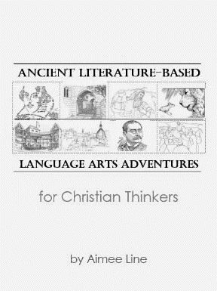
In this hands-on Language Arts experience, students read, write, research, design, and act their way through four World Literature-themed Language Arts adventures with a degreed English teacher and curriculum writer. The year is divided into four units. Each unit incorporates a whole-class reading and in-depth analysis of an ancient-literature-related novel, a map activity, a hands-on project, an analytical essay, additional period-related reading and research reports, and a creative-writing challenge culminating in a unit portfolio displaying the student’s accomplishments.
The instructor edits and evaluates essays, provides vital feedback, tracks the completion of homework assignments, and provides parents with private online access to student scores. This close editor-writer interaction fast tracks student writing growth.

Scope of Language Arts Topics:
- Writing topics and genres: paragraph structure, essay structure, methods of revision, literary analysis essay, creative non-fiction, short story, persuasive essay, sensory detail, showing versus telling, poetry.
- Research concepts: annotation, summary, sources, note cards, research paper, introduction to documentation.
- Literary concepts and devices: mythology, etiology, acrostic poetry, point-of-view, plot structure, personification, alliteration, simile, pun, hyperbole, chiasmus, soliloquy, fable, porquoi tale, fairy tale
- Grammar-as-related-to-writing: locating subject and predicate, prepositional phrases, sentence fragments and run-ons, coordinating conjunctions, subordinating conjunctions, sentence combining, appositives, semi-colons, participial phrases, dialogue punctuation.

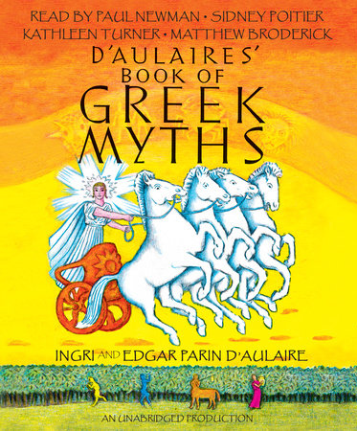

Book List: (slight revisions to list may occur before 7/1/2021)
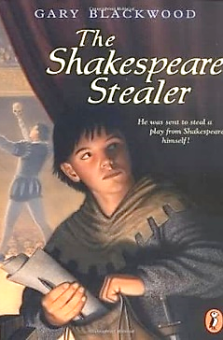
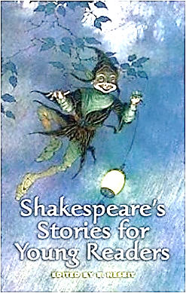
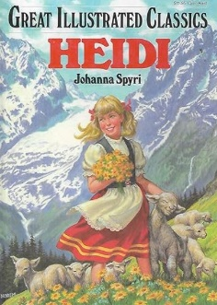
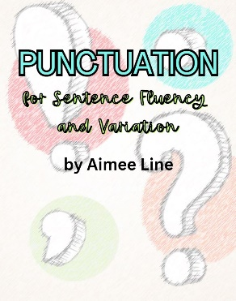
World Literature-Based Language Arts Adventures by Aimee Line (covered by book fee), World Literature-Based Language Arts Supplemental Resources Pack (covered by book fee), D'Aulaire's Book of Greek Myths by Parin and Ingri Parin d'Aulaire, The Bronze Bow by Elisabeth George Speare, The Shakespeare Stealer by Gary Blackwood, Shakespeare’s Stories for Young Readers by E. Nesbit –or—Shakespeare for Children Audio CD as told by Jim Weiss, and Heidi by Johanna Spyri
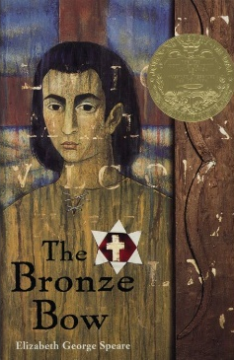

Plan Ahead: Middle School Language Arts classes follow a 3-year
rotation. Students who participate are well prepared to enter
Fundamentals of Writing in 8th or 9th grade.
2025-2026 American History-based Adventures for Christian Thinkers
2026-2027 Geography-Based Adventures for Christian Thinkers

www.aimeeline.com

